
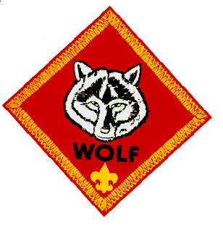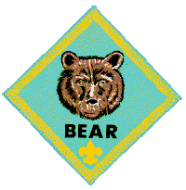Pack 532
2012-2013 Pack Celebration
 | September | October | November | December | January | February | March | April | May
Sanctuary Set-up | Den 13 | Den 6 | Den 3 | Den 7 | Den 8 | Blue & Gold | Den 1 | Den 4 | Den 2
Welcome Wagon | Den 3 | Den 2 & 7 | Den 9 & 13 | Den 1 | Den 11 | Blue & Gold | Den 9 | Den 5 | Den 8
Opening Ceremony | Den 11 | Den 4 | Den 7 | Den 6 | Den 2 | Blue & Gold | Den 7 | Den 13 | Den 9
Song | Den 7 | Den 2 | Den 5 | Den 8 | Den 9 | Blue & Gold | Den 8 | Den 3 | Den 4
Roll Call | CM/ACM | CM/ACM | CM/ACM | CM/ACM | CM/ACM | Blue & Gold | CM/ACM | CM/ACM | CM/ACM
Achievements | CM/ACM/ PAC | CM/ACM/PAC | CM/ACM/ PAC | CM/ACM/PAC | CM/ACM/ PAC | Blue & Gold | CM/ACM/ PAC | CM/ACM/PAC | CM/ACM/ PAC
Skit | Den 4 | Den 1 | Den 2 | Den 3 | Den 1 | Blue & Gold | Den 13 | Den 2 | Den 7
Advancements Ceremony | CM/ACM/ PAC | CM/ACM/PAC | CM/ACM/ PAC | CM/ACM/PAC | CM/ACM/ PAC | Blue & Gold | CM/ACM/ PAC | CM/ACM/PAC | CM/ACM/ PAC
Neckerchief Ceremony | CM/ACM/ PAC | - | - | - | - | Blue & Gold | - | - | CM/ACM/ PAC
Cubmaster's Minute | CM | CM | CM | CM | CM | Blue & Gold | CM | CM | CM
Closing Ceremony | Den 14 | Den 6 | Den 4 | Den 13 | Den 14 | Blue & Gold | Den 6 | Den 1 | Den 3
Sanctuary Clean-up | Den 6 | Den 5 | Den 11 | Den 5 | Den 3 | Blue & Gold | Den 2 | Den 7 | Den 5
HUMC Can Recycling | Den 1 | Den 8 | Den 14 | Den 9 | Den 4 | Blue & Gold | Den 3 | Den 6 | Den 1
Responsibilities
Rev. 0 9/5/2012

